HW1 Selection Sort, Bubble Sort and Binary Search

0616098 黃秉茂

CPU time (sec.)利用FloatToStrF，結果會是四捨五入到小數點第四位

Chart的縱軸CPU time單位是msec.而非sec.，是為了放大數值

run-all會一次執行Generate Random Number’, ‘Selection Sort’, and ‘Bubble Sort’，次數和資料成長量可靠輸入控制。其他button皆是只執行一次，但也會加入Chart

執行結果：

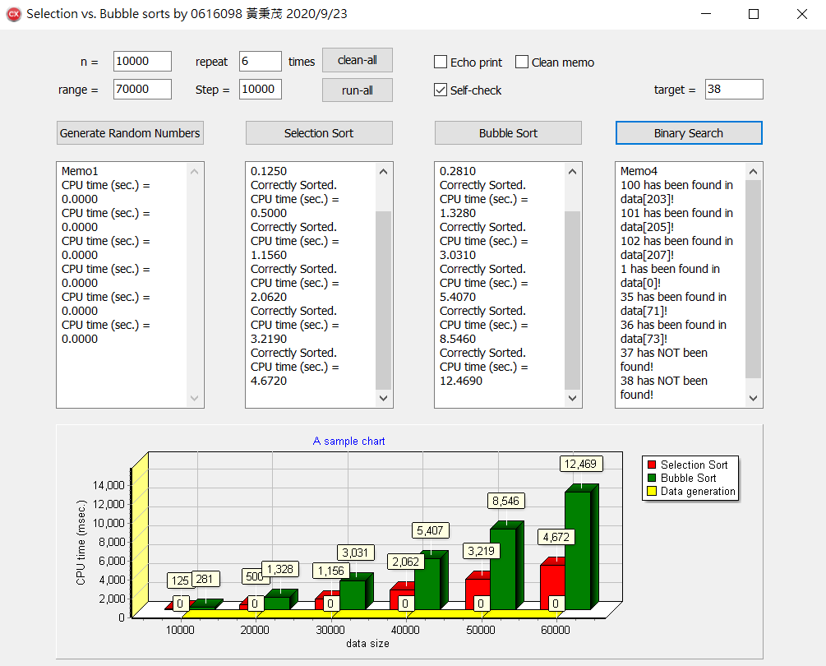

Edit：

n：data size

range：data ranging in [1, range]

repeat：repeat times

Step：每到新的iteration，會增大多少個data size

target：the target use‘Binary Search’to find

Button：

Generate Random Number：generate n random numbers

Selection Sort：sort n random numbers with ‘selection sort’

Bubble Sort：sort n random numbers with ‘bubble sort’

Binary Search：find target with ‘binary search’

clean-all：clean all the memos and chart and initialization

run-all：run‘Generate Random Number’, ‘Selection Sort’, and ‘Bubble Sort’respectively many times, and draw the result on the chart

Check-box：

Echo print：print each data with index in array

Self-check：check if the array is sorted

Clean memo：clean the memo before printing output